Woodward Christian Academy

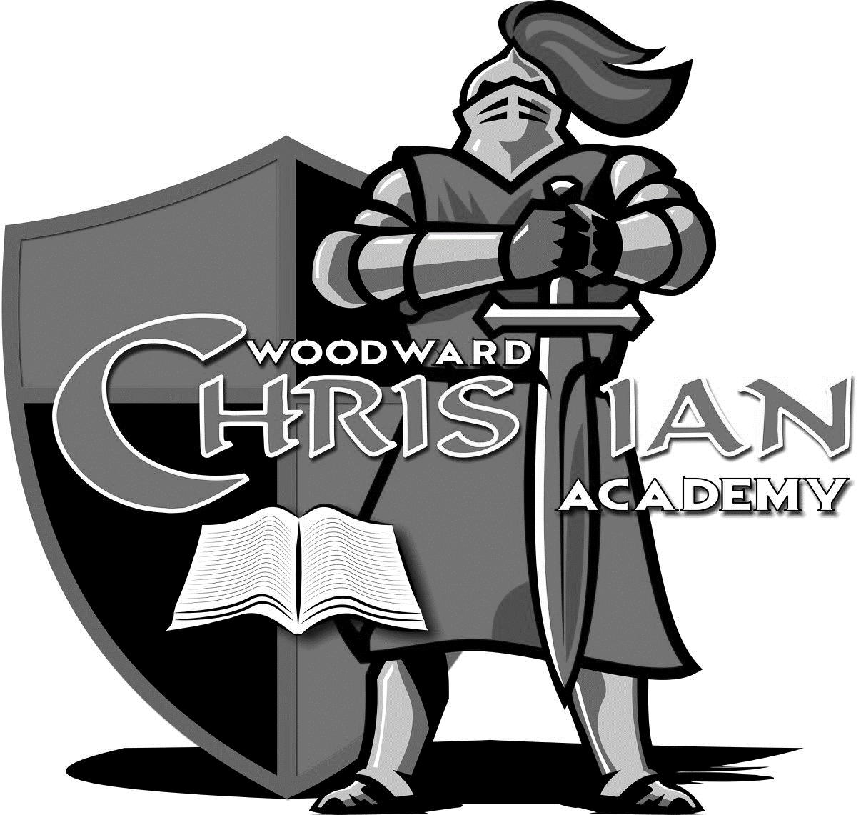

Homeschool Handbook
2017/2018

WELCOME
You have chosen to partner with Woodward Christian academy in homeschooling your child or children. It is our goal to support homeschoolers by:
- Diagnostic testing for incoming students to insure that they are placed correctly in the ACE curriculum.
- Ordering and distributing curriculum (PACEs) and score keys.
- Administering PACE tests, scoring PACE tests, and recording PACE test scores in our computerized record keeping system.
- Offering help and information to homeschool parents.
- Providing quarterly report cards for each homeschooled student.
- Maintaining an official record of the student’s grades and academic progress.

When homeschooling through WCA, we expect homeschool parents to:
- Keep a written attendance record, recording dates and times that homeschool has taken place.
- Keep homeschool students moving forward at a pace that is challenging to them. Students who do not test at least twice per quarter in each subject are considered to be truant and will be reported as such to the authorities.
- Follow the procedures outline in this handbook.
- Prepare students for testing when each PACE is completed.
DIAGNOSTIC TESTING:
All students who have learned to read, including high school students, should be tested for accurate academic placement. These tests cover material presented through the eighth level and Algebra 1 concepts, and they are necessary to identify learning gaps. WCA will need to perform diagnostic testing on children entering ACE’s homeschool program. On the day of testing, the student should have a good night’s sleep and a nutritional breakfast. Testing often takes two three hour sessions to complete.
Diagnostic testing helps WCA place the student exactly where he or she needs to be in each subject. Once testing is complete, a school administrator will let you know where your child tested in each area and PACEs will be ordered.
SETTING UP YOUR LEARNING CENTER:
Here are some practical considerations that will make it easier for you to homeschool-
- Select a room in which the student can work with minimal distractions. Anything that helps the student’s learning environment is an educational asset. Whatever place you choose, make sure that it has good lighting. This could be the corner of a family room or spare bedroom. Some families use the dining room or kitchen table.
- If you have more than one student, each should have an individual work space.
- You will need to provide a separate area where the student scores. This could be a sewing machine table, a corner on the kitchen counter, a game table, etc. If available, choose an area that allows the student to stand upright. Whatever you choose, use it consistently.

SUGGESTED SCHEDULE:
- Schedule PACE work sessions with 10-minute breaks. If the break is too long, it is hard to resume work. Television should not be allowed during breaks.
- Take breaks outside whenever possible. Students need a change of focus for healthy eyes.
- Use breaks for restroom, snacks, or free time.
- PACE work time recommendation
      - 40 minutes for Grade Levels 1-6
      - 50 minutes for Grade Levels 7-9
      - 60 minutes for Grade Levels 10-12
LEARNING CENTER FORMS:
- Each student will need a goal and a star chart.
- Goal cards help the student’s keep track of their goals in each subject.
- Star charts are a visual way for the student and parent to keep track of how many tests per quarter have been passed.

ACADEMIC RECORDS:
As part of our homeschool program, WCA will take care of your student’s academic record keeping. Each quarter, WCA will issue a progress report (or report card) for homeschool students.

We do recommend that homeschool parents keep attendance. Document every day that you homeschool and during what hours the student was engaged in learning activities.

PACE WORK:
PACEs are color coded as follows:
- Math- yellow or gray
- English- red
- Word Building- purple
- Literature and Creative Writing- coral
- Science- blue
- Social Studies- green
- Bible Reading- tan
- Animal Science- turquoise
- Electives- various colors with white

WCA will issue one/two PACEs per subject. At home, give the PACEs, one in each subject, to the student. Help the student fill out the Goal Card (see next section). Typically, the goal is 3-4 pages in each subject per day. It is important that the student take no more than three weeks to complete and test on a PACE. The normal time needed is two weeks.

SETTING GOALS:
The Goal Card is designed for daily entries each week. The card is two-sided; thus it can be used for two weeks. The Goal Card is pinned to a small bulletin board in the student’s work area, or can also be kept in a binder. Each day as the student completes his goals in each subject, he enters reasonable goals for the next day and draws a forward diagonal line through each completed goal. (Do not allow students to scratch out or cover up goals.) The student must be required to enter specific page numbers (i.e., 12-16) in each subject, using a blue ink pen. Occasionally, goal changes are necessary. These should be made by you, the parent, rather than by the student.
When you begin, explain how to set daily goals. For Math, English, and Word Building, the student enters actual page numbers for each subject in pen. For Science and Social Studies, the student should enter actual page numbers or sections, such as I, II, or A, B, whichever is best, depending on page arrangement and the complexity of problems and equations. For Basic Literature, he should enter specific page numbers of the resource book being read or questions to be answered. Entries such as “Test” and “Review” are also acceptable; however, you must guard against the student delaying a Test. Such goals should not be entered two days in a row. A review day should have specific activities such as writing or typing all previously missed questions on Checkups and Self Test. The student scores the PACE work according to built-in “score strip” controls. The student should always score before and after a Checkup and after the Self Test.
When the goals are completed, scored, and rescored, the student places a forward diagonal line on the Goal Card across the page numbers completed. He immediately writes in the next day’s PACE goals. Since he has just worked on the subject, he can better calculate how much academic work can be completed the next day. By the end of the day, he should have completed all his goals, marked them on the Goal Card, and set new ones for the next day. The student should take care to keep the Goal Card neat. Implement a system of follow-up that provides corrective measures when he does not complete goals. However, consideration should be given for illness, unusually difficult problems, disruptions, “idealistic goals,” etc. Goal setting may be relatively easy for some students but more difficult for others. Do not permit the student to sit idle and not produce. The student may need a short break or encouragement. Identify when the student needs motivational assistance, and give more attention. Use the same basic guidelines for setting goals as given in this Manual, but allow up to 15 days for completing the PACE.

Goal Checking:
GOAL CHECKING is done by the parent and is a means to evaluate how well the student is doing in each subject. If the student has many RED X’s, it is time to ask questions and discover why this is happening. Is the student just being careless? Is the student failing to read the material or instructions? Does he need encouragement or help with the academic material?

Checkups:
A Checkup is a mini-test over a section of the PACE. If mastery in an academic area has not been achieved, the Checkup will reveal this weak area. Before a student begins work on a Checkup, he should be encouraged not to look back to previous pages while completing the Checkup; he should view it as a “mini-test”. All questions on the Checkup should be scored and wrong answers corrected before moving on in the PACE.

Self Test:
Before a student begins work on the Self Test, be sure all activities and Checkups are completed, scored, and corrected. After the student has reviewed the Checkups, initial the Self Test. When he takes the Self Test, he should not look back at previous pages. This is NOT an open book test. The Self Test is a pretest whereby the student can determine if he is ready for the PACE Test. After the Self Test has been scored and corrected, review the student’s work. If a score of 90 percent or better is not achieved on the Self Test, this indicates that more review is needed to obtain mastery. Spend whatever time is necessary to ensure understanding and mastery of the concepts. When the review is complete, the student is ready to test. Homeschool students will test at WCA as soon as possible after his or her review is complete. Testing will done according to the Homeschool Coordinators schedule.

PACE Test:
To prepare for the PACE Test, quiz the student with questions from the Checkups and Self Test the day before the Test is given. Look for section(s) in which he did not seem to understand the material. Have him review any concepts or materials he does not understand. Have him write answers for questions he missed on the Checkups and Self Test. All testing will be done at WCA with the Homeschool Coordinator in a testing area. Parents are not to accompany student to the testing area. Completed PACE’s and any additional required work MUST be brought to the school so staff can verify completion and accuracy. If the student scores below 80 percent on the PACE Test, this demonstrates inadequate understanding or insufficient mastery of skills. The problem can often be avoided by properly reviewing before the Self Test and giving attention to mastery of concepts listed in the Goals. If the student does not pass the PACE Test with an 80 percent or higher, WCA will order another PACE, AT YOUR EXPENSE. When it comes in, the student should rework the entire PACE and retake the Test. The original score is then replaced by the new score if it is 80 percent or higher.

WORKING THE PACE:
Scoring Procedures
As the student progresses through the PACE, he will come to score strips. At each score strip he must stop working and ask for permission to score. Scan all pages to be scored to be sure all answers are complete. Proceeding to the area set aside for scoring, the student checks his answers with the proper Score Key and marks any wrong answer with a red “X” beside the question number. When all pages have been scored, the student puts a red “X” in the first box of the score strip. He then returns the red pen and the Score Key to their proper places and returns to his work area. The student should correct any wrong answers, and with permission rescore at the designated scoring area. The student should not proceed in the PACE until the answers preceding the score strip are all correct.
Procedures for Scoring PACEs:
Score Keys must be kept in an area where the parent can best monitor them at all times. Only a RED PEN is to be used at the scoring area. Score Keys should be kept in a secure place before and after school hours.
Score Strips:
When a student completes his PACE work up to a score strip:
- He must ask for permission to go to the scoring area.
- He MAY NOT take a pencil to the scoring area for any reason.
- At the scoring area, he finds the Score Key that matches the PACE and scores.
- All wrong answers must have a RED X place by them.
- After scoring, the student also places a RED X in the first box of the score strip while at the scoring area.
After Scoring:
If the student DID NOT have any wrong answers, he may continue working in that PACE or go on to the next PACE subject listed on his Goal Card. If the student HAS wrong answers, he must go back to his work area and correct the wrong answers and rescore before going on to the next subject listed on his Goal Card. All goals must be completed before going to the next day’s goals, and completing goals requires correcting wrong answers and rescoring.
Correcting Mistakes:
After correcting all mistakes and while at his work station, the student places a PENCIL X in the second box of the score strip. Then he asks for permission to rescore. When all incorrect answers have been corrected and while the student is at the scoring area, he places a RED X in the third box of the score strip. When everything on a page is correct, it is helpful to circle the page number in RED.

ASSISTING THE STUDENT IN LEARNING:
Motivation is the positive element that inspires achievement. Your consistency, love, and interest will build the student’s self-image and confidence and inspire him to further success. Set rules; however, you do not want to communicate a distrustful attitude that discourages the student’s confidence in himself and you. He must feel that you trust him but also be aware that you are watchful. Positive affirmation is usually more effective than negative communication. An atmosphere of trust can be enhanced through subtle expressions of confidence. Verbally communicate your appreciation when he shows good behavior. A pat on the shoulder, a smile, a request for help, or words such as “I am glad we are homeschooling” or “I have confidence in you” will encourage success. A student who feels someone has confidence in him will tend to act accordingly. Praise, compliment, and encourage in order to build character.

ANSWERING QUESTIONS BY ASKING QUESTIONS:
The student may not be accustomed to assuming responsibility for learning nor adapted to perseverance and challenge. The normal first reaction to a difficult equation or question may be to ask for help. Learning is the student’s responsibility, and information and skill building are in his PACE. You are a leader and an inspirer of learning. Most of the time the student’s problem is lack of interest or confidence. Your greatest responsibility and most important function is exercised in these cases. Words of confidence, encouragement, reassurance, and sincere personal interest provide the plus factors. Opportunities for motivation come, especially when a student has an academic problem that demands additional help.

When a student calls for academic assistance, ask leading questions that focus the student’s attention on the solution. If the question is immediately answered, his mental inquiry may stop short of learning experience. You should not answer the PACE questions, but determine the nature of the problem and help the student find the answer.

If the student realizes he can get his questions answered without having to work at it, he will become lazy and resort to asking for help rather than taking responsibility to master the problem himself. “One measure of the effectiveness of any teacher is the rate at which he makes himself unnecessary to his pupils…..”—Dr. C. B. Eavey

The strength of the Accelerated Christian Education curriculum is in its design, which allows a student to learn independently of your academic knowledge of subject matter. Your greatest joy is realized as the student matures toward less and less dependence on you.
The A.C.E. curriculum is designed to facilitate learning rather than teaching. You will become adept at assisting students in digging out answers and gaining insights into learning how to learn. When the student asks an academic question, he should be given help, not the answer. You might respond in any of the following ways:
- “How may I help you?”
- “Read aloud the instructions for the particular sections or problems.” (See if he understands key words.)
- “Explain in your own words what you think you are supposed to do.”
- “Work out the problem while I listen to your explanation.”
- “Where is the example or paragraph in the PACE that relates to this question?”
- “Review the examples (or previously completed problems).”
- “Is the question asking for a person, place, name, or date?”
- “Would computer software, an encyclopedia, or dictionary help?”
While responding to the student, observe any possible oversights or mistakes (subtracting instead of adding, multiplying instead of dividing, negative instead of positive, north instead of south, etc.)
Feel free to call the school if you need help helping your child!
THINGS TO KNOW:
- Homeschool students should follow school dress codes while on campus
- STUDENTS ENROLLED AS HOMESCHOOLERS AT WCA MUST TEST AT LEAST TWICE IN EACH SUBJECT PER QUARTER. FAILURE TO DO SO WILL RESULT IN THE STUDENT BEING REPORTED AS TRUANT TO THE AUTHORITIES.
- Score keys are property of WCA. Lost, damaged, or un-returned score keys will be charged to you at $10 each.
- Failed PACE’s must be re-ordered. The charge is $10 per failed PACE.
- Paces and any additional required work must be brought to the Homeschool Coordinator prior to testing in order to verify accuracy and completion.
- Testing will be allowed only during established days and times when the Homeschool Coordinator is available.
- Parents will not be allowed into the testing area with the student.
- PACE’s will not be ordered for students whose accounts have an outstanding balance.
- Students must complete 12 PACE’s in each subject to complete a grade level.
- Not following the procedures outlined in this handbook may result in the student failing PACE tests.
- If your child will be participating in extra-curricular activities at the school (P.E., art, science), please call in on days your child will be participating to confirm the schedule has not changed for that day.

Parent Responsibility Pledge
“I hereby pledge to pay my financial obligations to the school on the date due and understand that it may be necessary to withdraw my student if proper arrangements are not made on a past due account.”
“I absolve the school from liability to me or my student because of any injury to my student at school or during any school activity, including but not limited to art, science, music and P.E.”
I agree to uphold and support the high academic standard of the school by providing a place at home for my student to study and giving my student encouragement in the completion of homework or assignments.”
“I appreciate the standards of the school and do not tolerate profanity, obscenity in word or action, dishonor to the Godhead and the Word of God, or disrespect to the personnel of the school. I hereby agree to support all regulation of the school in the applicant’s behalf and authorize this school to employ discipline as it deems wise and expedient for the training of my student.”
“I understand the school reserves the right to dismiss any student who fails to comply with the established regulations and discipline or whose financial obligation remains unpaid.”
“I have read the Homeschool Handbook and understand the Terms stated on the Application and agree thereto.”

Student’s Name_____________________________

_______________________________ ___________________
Father’s Signature Date

_______________________________ ___________________
Mother’s Signature Date

WCA Homeschool Option
Enrollment: $50 one time, non-refundable enrollment free
Cost: $50 month tuition plus $25 month book fee (required 72 PACE’s a year).
Parent Responsibilities: The parent will be responsible for the student’s day to day learning and PACE work. This includes over-seeing scoring, goal keeping, test review and maintaining academic integrity as well as turning in completed PACE work and any additional requirements to the Coordinator. The parent is also advised to keep a daily attendance record and log of hours spent on school work.
We highly encourage Homeschool parents attend the Parent Orientation in August.
School Responsibilities: WCA will be responsible for ordering curriculum and score keys, the student’s PACE testing and scoring, and for the student’s academic record keeping.
Benefits for the Homeschool Family: The student will have a complete, formal, academic record, complete with an official transcript and a high school diploma upon completion of graduation requirements. WCA will send a copy of the student’s official transcript and records to institutes of higher learning when requested.
The student is invited to participate in special classes such as P.E., art, penmanship competition, music and science lab (to include the science fair). 9th – 12th grade is required to participate in the above classes.
The student may participate in extra-curricular school activities such as field trips, programs, Truth Readers, special events and the awards ceremony.
When PACE work is being performed at an acceptable level and the student meets ACE’s age requirements, the student may attend student convention with WCA.
The student may take part in WCA’s graduation ceremonies once all graduation requirements are met. They will be graduated as a Homeschool class.
TESTING REQUIREMENTS:
PACE’s and any additional required work MUST be turned in to the Homeschool Coordinator for review prior to testing. (The day before testing if possible)
If violations arise, testing will not be allowed to be completed. (IE: PACE’s not complete or incorrect, cheating, etc.)
Parents may NOT accompany student to the testing area.
Testing must be scheduled during established Homeschool hours when the Coordinator is available. Testing will only be conducted during the established days and times.

